Prairie Heart Institute of IL
In conjunction with
Boyd Healthcare Services
Presents:
HANDS-ONLY CPR
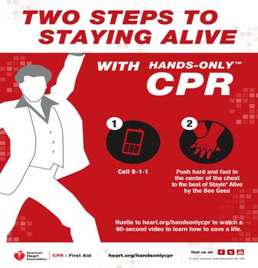

Do You Know Hands-Only CPR?
‘Sudden Cardiac Death remains the leading cause of mortality in the Whole World.’
Come and Join us. Let us explore how a Lay Person can make a difference in someone else’s life, including their own!!!
Boyd Healthcare Services mission is to provide quality health care and promote wellness for the residents in our region through Health Services, Information Resources and Education.

Guest Speaker: Chelsey Jennings R.N.
Prairie Heart Institute STAT Heart Coordinator

There is No Fee to attend.
Seats are limited.
Lunch will be provided.

Date: August 14, 2019
Time: 11:30 AM - 1:00 PM
(Lunch starts at 11:30 AM)
Where: Knights of Columbus Hall
Route 67, Carrollton, IL 62016
Register by phone: 217 942 6946 ext. 1202

